=

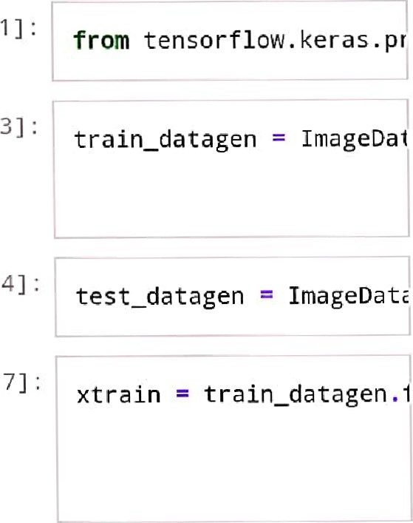

In

In

In

C

Found 4317 images belong ing to 5 classes .

# IMAGE AUGMENTATION

|  |
| --- |
| from tensor from tensor |

 flow. keras.mc flow. keras . lé

# CNN MODEL

|  |
| --- |
| model Sequential( ) model . add( Convolution2D model .  model.add(F1atten( ) ) # ) # Fully connected layer: model . model model |
|

In [9]

# COMPILE THE MODEL

In CI O] , model . compile (optimizer:

SAVE THE MODEL



model . save( ' Flower . h5 ' )



image to al

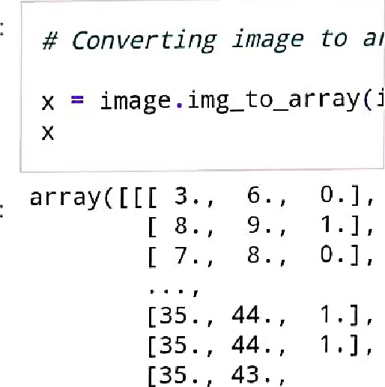

43

In

Out[20]

 o . ] 

[30 . , 36.



1. , , 38



1. 39. ,

[ 7 . ,

[ 5 . ,

22

 [ 1 9 . , 24 

[23 . , 29



[ [1 7 . , 20 . ,

|  |  |
| --- | --- |
| [23 . , 27 | 2 . ] , |
| [24 . , 30 | 2 . ] , |

[23 . , 27

[23 . , 29

[21 . , 27



[ [1 6 . , 1 9 . ,

[23 . , 28

[26 . , 31

[1 9 . , 23

[25 . , 27

[1 9 . , 24



[ [ 1 7 . , 20 . ,

[22 . , 26

[26 . , 3

[1 8 . , 21

1. . , 24
2. . , 25

 dtypezfIoat32)

|  |
| --- |
| # Expanding dimensions x np.expand_dims(x,axj |

ın [21 ] :

Out [21 ] . array( [ [[ [ 3 . , 

[ 8 . ,

# [ 7 . ,

[35 . , 44



[35 . , 44



[35 . , 43



[ 6 . ,

[ 6 . ,

[30 . , 36. ,

[30 . , 38 . ,

39 . ,

[ 7 . ,

[ 5 . ,

〔1 9 ·

ㄇ 9 ·

〔23 .

|  |  |
| --- | --- |
| 1 7 ·  [ 23 · L24 . | 20 . |
| [ 23 · | 7 |
| 〔23 ·    1 6 · | 9  7 |
| 〔23 · | 2 8 . |

[ 26 ·

ㄇ 9 ·

[ 2 5 .

[1 9 . , 23

[25 . , 27

[1 9 . 24. ,

|  |  |
| --- | --- |
| 1 . ] 1 ,  ı . ] | [ [17 . , 20  [22 . 26 . ,  [26 . 31 . , |



1. . 
2. . 25 . ,  dtype:fIoat32)

In [22] :

model.predict(x)

|  |  |
| --- | --- |
| Out [22] : | array( C  9. 1 82201 6+01 , 2 . 1 1 05427 e-24, 1 .6366634+27] ] , dtype=fIoat32) |

[8. 1779763+02,

In [25] :

|  |
| --- |
| # Testing  img - image. load_img( x = image .  np . expand_dims (x , axi pred — np . argmax(model op[pred] |

|  |  |
| --- | --- |
| Out [25] | • dandelion |

op = [ ' daisy ' , 'dandelior pred = np . argmax (model . F op[pred]

In [26]

Out [26]dandelion